Lecture 1
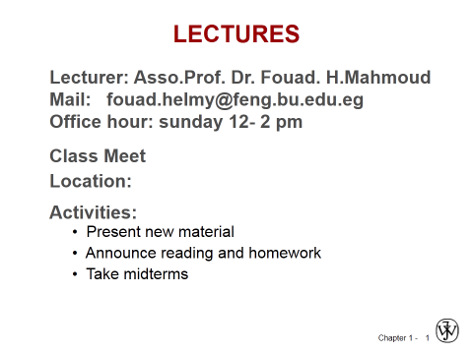
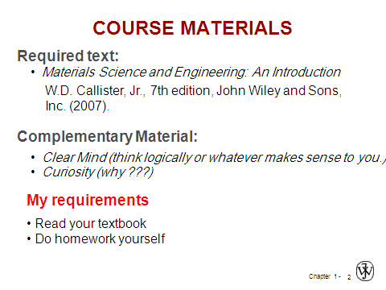
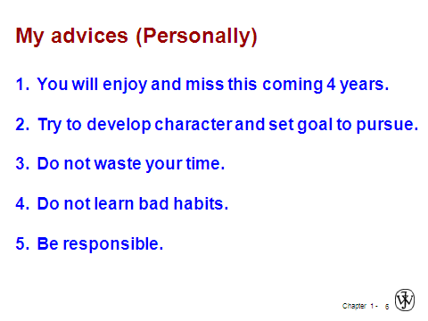
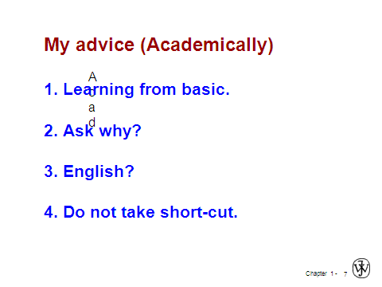

COURSE PLAN
Remarks | practice | Theory | Week No.
1. Assignments will be given at the end of each chapter(Theory)  2. Surprise quizzes will be distributed uniformly in 16 weeks (min 3) | Introduction | Introduction to engineering materials | 1
 | Assignment | Crystal structure | 2
 | Assignment | Binary solution | 3
 | Assignment | Phase diagrams | 4
 | Assignment | Phase diagrams | 5
 | Assignment | Iron-carbon phase diagram | 6
 | Assignment | Iron-carbon phase diagram | 7
 | Determination of % of Carbon | MID THEORY EXAM | 8
 | Annealing | Single crystal deformation | 9
 | Normalizing Processes | Strengthening of materials | 10
 | Hardening & Tempering Processes | Heat treatment fundamentals | 11
 | Mechanical Properties of Heat Treated Specimens | Heat treatment fundamentals | 12
 | Mechanical Properties of Heat Treated Specimens | Ferrous alloys | 13
 | Review | Ferrous alloys non | 14
 | Oral exam | Review | 15
 | FINAL THEORY EXAM |  | 16

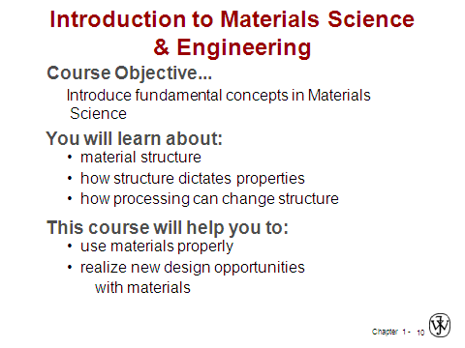
Lecture number 1
